Sorting Algorithms
Bubble Sorting:
The main idea of the bubble sort is to keep comparing the adjacent elements and if they are in correct order then it will stay as it is and other two adjacent elements will be compared and if they are not in correct order then it will be compared and will swap until the array or the list is fully sorted.
Just like the bubble in the water pop up to the surface so in this the largest will pop up and will move to the last of the list or array.
The bubble sort has passes:
- In first pass the largest will move to the end,
- In second pass the second largest will move to the end and so on until the whole list is sorted.
Number of passes=number of elements – 1.
In bubble sort two loops will be required, one for passes and one for the comparison, the inner loop will be for the comparison and the outer loop will be for the passes, also when the first passes is done mean that the largest element reached to the last of the list or array so in the second pass the last element will not be compared so that’s why the inner loop will run (-i) of outer loop. Mean that the outer loop increases the comparison in inner loop will be decreases.

Insertion Sort:
In this algorithm the array or the list will be divided into two parts the { 1: (sorted sub list), 2: (unsorted sub list)} and then the comparison will be start from the unsorted sub list part, One element will be taken from the unsorted sub list and will find the appropriate place for that value or elements in sorted sub list and insert the value in that place.
Take the first element as a sorted sub list because a single value is always in sorted form.

Selection Sort:
In this type of sorting the array will also be divided into two sub arrays, but here the sorted array will start from zero.
The next step is to find out the minimum element from the unsorted array or list, and that minimum element will be swap with the first element of the unsorted array or list.
Two loops will be used here, the outer is for the passes and the inner is for finding the minimum value and for swapping.

Quick Sort:
Basic idea behind the quick sort is, that we will choose one element which is known as key element or pivot element, can choose any random element as pivot element.
The Quick sort is based on the “divide and conquer rule”.
Divide and Conquer Technique:
The array will be divided into sub arrays, and this process is known as partitioning, and this partitioning is the backbone of this sort, the main thing to know in this sort that how to partition the array or the list, if you get this then the remaining will be easy for you.
Partitioning logic:
The values smaller than the pivot element will be to the left of the pivot and the values greater than the pivot will be to the right of the pivot element, if there is same value as the pivot so it can go either way and this is how the pivot will get it’s correct final place, but it cannot be assure that the element to the left and right of the pivot will in sort order within itself, now the same process will be apply for the left and the right partition.

Code explanation:
Two variable will be take (start ,end) that will swap the elements if they are greater or smaller than the pivot, the start will be incremented until the element is greater than the pivot and the end will be decremented until the element is smaller than the pivot, and in this way we will swap the start and the end with each other, but when the start exceed the end then the swapping of start and end will be start and we will just swap the pivot with the end and in that way the pivot will get their final correct space.
Recursively this principle will be applied on the array or the list to sort the full list, two functions will be write for it one for the partitioning the array or the list and the other for recursively applying the partition function.

Merge Sort:
In this algorithm the array or the list is divided into sub array or sub list until it got one element in it, and then all the sub list merged in that way that the final array is sorted.
Steps in merge sort:
- Divide the array into two equal sub arrays by finding out the mid position and then divide it there, the mid position can be found by adding the lower bound and upper bound and then divide it by 2, these steps will be repeated for the sub arrays also and will kept going until each sub array are consist of one element in itself.
- The second step of this algorithm is to merge the sub arrays in such way that the final array is a sorted one.
Code:
The code will contain the function which is (merge sort) it will divide the array and the main merging function that will merge the divided parts of the array in sorted manner.

Heap
It is tree base data structure where all the nodes are arranged in a specific order, there are two main types of heap.
Representing binary tree in an array form:
Array will represent the binary tree in such a way that the zero index will be filled with the root element and next element will be filled with left most element of the level 1 of binary tree and going toward right, when level 1 becomes finished, it will jump to level 02, start from the left most and so on.
Now in array representation we don’t know which one is the root node, parent node, and child node, for knowing about this it has specific formulas which are following:
To know the parent, and children for the node at ith index are:
Parent = [(i-1)/2]
Left child = (2*i) +1
Right child = (2*i) +2
Note: All this will apply to a complete binary tree, if a tree is not a complete binary tree so then make it a complete binary tree and then represent it in array from.
To make a tree a complete binary tree, add empty nodes to the left side and in array representation the indices for that nodes will be left empty.
Max Heap:
Max heap is fully binary tree, and its parent node will always be greater than or equal to its child node. These are the two main properties of the max heap.
In max heap the root node will always be the largest node, and in this way, it helps you to find the largest value in the data structure very easily.
For example:
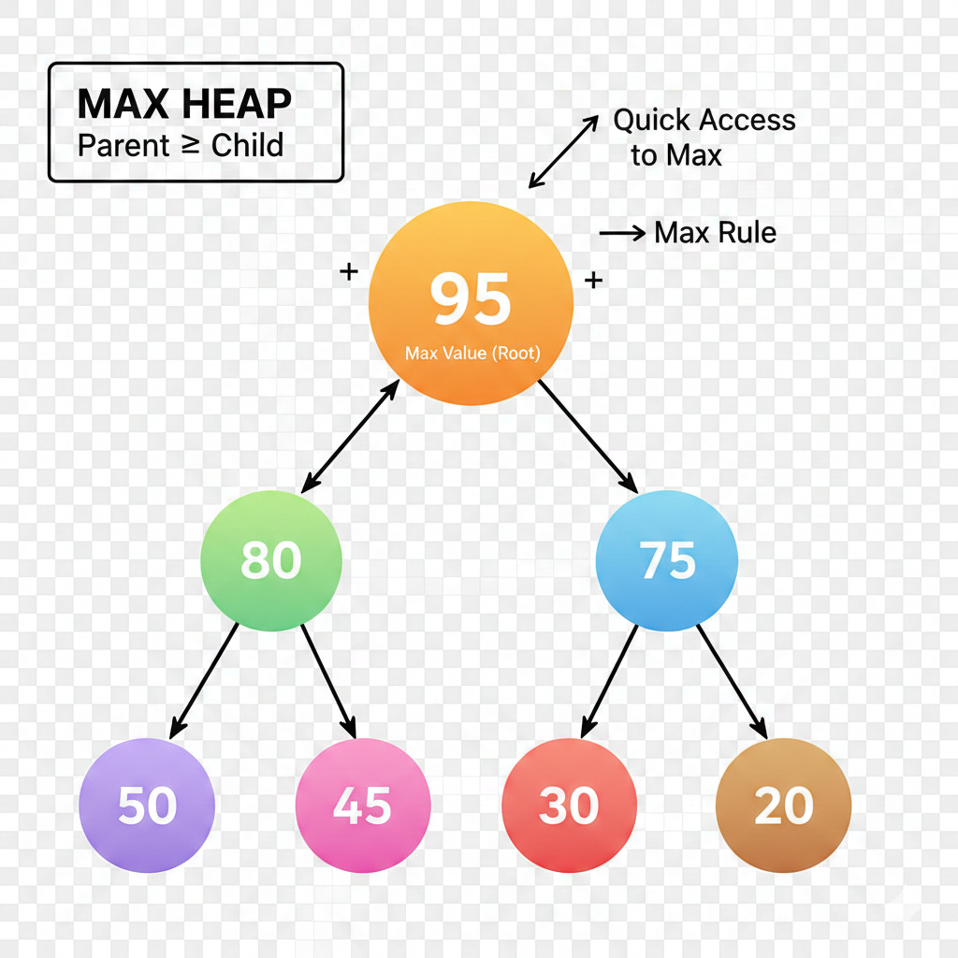

Inserting node:
In max heap the node will be inserted from the leaf nodes not from the root node, like if we have to insert 60 in the above heap tree so will insert it from the leaf side, the 60 will be inserted next to 50 now it is satisfying the complete binary tree property but does not satisfying the max heap property because the new inserted 60 node is greater than it’s parent which is not the property of the max heap so to gain the property it will be swapped until it get the property of the max heap and the swapping will be done by parent node formula in an array.
In simple a new node will be inserted to the left side of the tree, and the property of the max heap will be checked, if satisfying the property, no swap will be done otherwise it will be swapped until it gets the property of the max heap.
The time complexity to insert a node is O log(n).
Min heap:
It is the opposite of the Max heap; in this data structure the value of the parent node will always be smaller or equal to the child node.
The root node of the min heap will be the smallest value of the data structure and in this way, it helps you to find the smallest value easily.
For example:
